Project Planning Phase
Project Planning Template (Product Backlog, Sprint Planning, Stories, Story points)

Date | 27 September 2026
Team ID | SWTID-2026-9290
Project Name | Askly-AI FAQ Assistant
Maximum Marks | 5 Marks

Product Backlog, Sprint Schedule, and Estimation (4 Marks)
Use the below template to create product backlog and sprint schedule
Sprint | Functional Requirement (Epic) | User Story Number | User Story / Task | Story Points | Priority | Team Members
Sprint-1 | FAQ Knowledge Base | USN-1 | As a user, I can access a prepared list of frequently asked questions and answers so that I can find common information quickly. | 4 | High | Keerthika R, Manju R
Sprint-1 | FAQ Knowledge Base | USN-2 | As an admin, I can add or update FAQ questions and answers so that the information stays current. | 3 | High | Manju R, Keerthika R
Sprint-2 | Chat Interface | USN-3 | As a user, I can type my question in the chat interface so that I can ask the assistant for information. | 3 | High | Vagai Selvi E
Sprint-2 | Chat Interface | USN-4 | As a user, I can view the assistant's answer clearly in the chat interface. | 3 | High | Vagai Selvi E, Gopika K
Sprint-3 | Question Matching | USN-5 | As a user, I can receive a relevant FAQ answer when my question matches the available FAQ information. | 5 | High | Gopika K
Sprint-3 | Question Matching | USN-6 | As a user, I can receive a helpful fallback message when no suitable FAQ answer is found. | 2 | Medium | Gopika K, Mahalakshmi M
Sprint-3 | Integration | USN-7 | As a user, I can use the chat interface and FAQ matching together as one working assistant. | 4 | High | Gopika K, Vagai Selvi E
Sprint-4 | Testing & Finalization | USN-8 | As a project team, we can test common questions and fix errors before the final demonstration. | 3 | High | Mahalakshmi M, Manju R
Sprint-4 | Testing & Finalization | USN-9 | As a project team, we can prepare the final project output and demonstration. | 3 | Medium | All 5 members

Project Tracker, Velocity & Burndown Chart: (4 Marks)
Sprint | Total Story Points | Duration | Sprint Start Date | Sprint End Date (Planned) | Story Points Completed (as on Planned End Date) | Sprint Release Date (Actual)
Sprint-1 | 7 | 2 Days | 22 Sep 2026 | 23 Sep 2026 | 7 | 23 Sep 2026
Sprint-2 | 6 | 2 Days | 24 Sep 2026 | 25 Sep 2026 | 6 | 25 Sep 2026
Sprint-3 | 11 | 2 Days | 26 Sep 2026 | 27 Sep 2026 | 9 | 27 Sep 2026
Sprint-4 | 6 | 1 Day | 28 Sep 2026 | 28 Sep 2026 | 6 | 28 Sep 2026
For this project, the completed story points are 7, 6, 9, and 6 across Sprint-1 to Sprint-4. Team Average Velocity (AV) = (7 + 6 + 9 + 6) / 4 = 7 story points per sprint. Average velocity per day = 28 completed story points / 7 project days = 4 story points per day.


Burndown Chart:
A burn down chart is a graphical representation of work left to do versus time. It is often used in agile software development methodologies such as Scrum. However, burn down charts can be applied to any project containing measurable progress over time.
AI FAQ Assistant Burndown Chart data: Day 0 = 30 remaining points; Day 1 = 23; Day 2 = 23; Day 3 = 17; Day 4 = 13; Day 5 = 4; Day 6 = 0. Use these values to plot the actual remaining-work line for 22–28 September 2026.
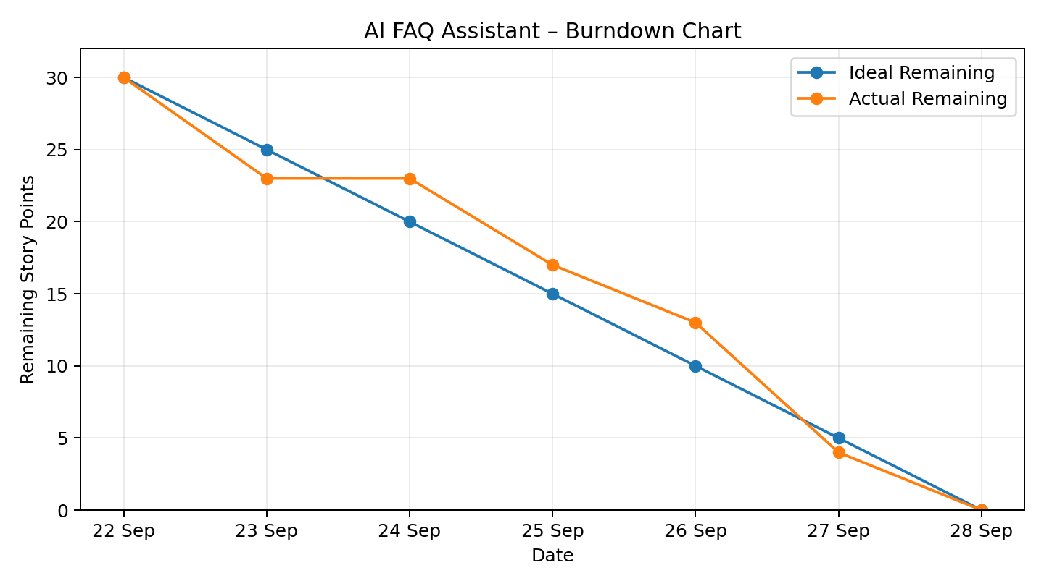
Burndown data used: 22 Sep–28 Sep 2026; total planned story points = 30. The ideal line shows the planned decrease in remaining work, while the actual line shows the reconstructed project progress.

